Homework 1: Matplotlib plot building
DSCI 410 Visualization for Data Science Winter 25

Collaboration Policy: You may work on this assignment with others.
Due: Sunday Jan 11th by midnight
Submission: A well-commented Python script or Jupyter notebook.
Points: 20 points (5 for each figure)
Description
I’ve made four figures relatively easily using ‘seaborn’. For this assignment, you must recreate each figure to an approximation using only ‘matplotlib’. The artistic details don’t need to be identical (e.g. colors only need to be similar), but all the relevant elements must be present and figure formatting must be comparable. The only seaborn functions you may use are for adjusting color palettes.
The figures can be found on the following pages.
Figure 1
For the first three figures you will use the “global development” data.
Figure 1 displays the average global fertility rate by year in the data as a time series. When plotting averages, it is easy to be misled into thinking that the values are data points and not estimated statistics. Therefore, it is good practice to plot a confidence interval around averages. To find the range of the 95% confidence interval within each year, use the following formula:
$$CI\left(x\right)=1.96\frac{σ_{x}}{\sqrt{n_{x}}}$$
Where $σ_{x}$is the standard deviation and n is the sample size.
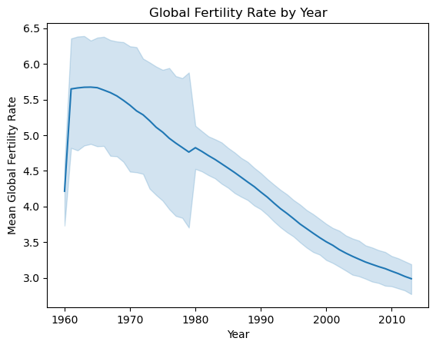
Figure 2
In this figure, ensure there is some transparency to the points, that the points scale by total population, and that the legend is correct. Note that you may need to rescale the population to be bounded on some range of point sizes for the legend.
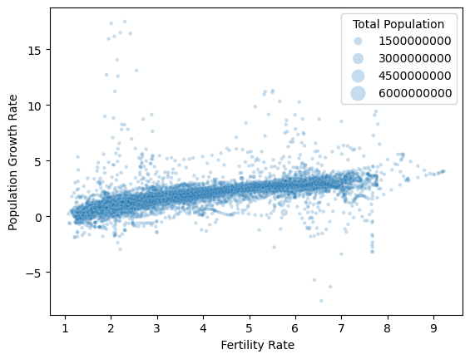

Figure 3
For this figure, you are to replicate ‘seaborn’s pairplot function. It is fine to use histograms instead of KDEs for the diagonal distributions.
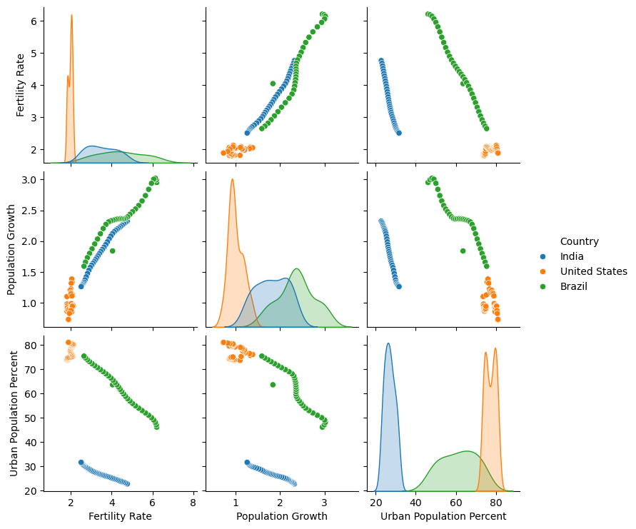

Figure 4
For the final figure, use ‘seaborn’ to load the ‘planets’ dataset: sns.load_dataset("planets")
Note the log scale on the x-axis.

